Chapter 3, Problem 13.

Calculate v₁ and v₂ in the circuit of Fig. 3.62 using nodal analysis.
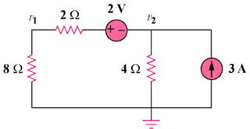

10 V

15 A

Figure 3.62
For Prob. 3.13.

